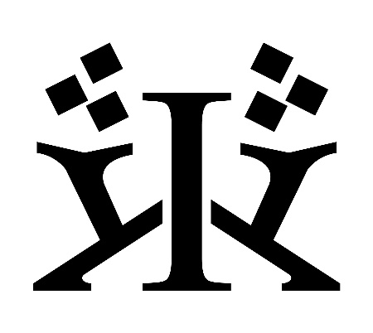

Copyright © 2023 Kalat World

All rights reserved. The illustrations, cover and contents are protected by copyright. No part of this booklet may be reproduced in any form without permission in writing from the publisher, except by a reviewer who wishes to quote brief passages in connection with a review written for inclusion in a magazine, newspaper or website.

First edition

Made in China

*Kalat World/Text - Dennis Kalat*

*Illustrations - Inge Laan*

[www.kalat.world](http://www.kalat.world)

Introduction

Hello, my name is Dennis Kalat and I’m a Dutch-Swiss medium living in the tiny Alp village of Haldenstein. Ever since I was a young kid I was already attracted by symbols and colours, they fascinate me.

I didn't know anything about oracle cards at the time, but I already experienced more paranormal impressions than I could handle at that age. That was the reason I blocked my gift as much as possible for a long time, until I bought an oracle deck many years later. With that, I set a lot in motion; the colours and symbols were the order of the day again!

A few years ago I became visions and it seems like I have been guided towards creating the deck I am presenting now.

The Kalat cards tell a good story, it has a lot of depth and a solid structure due to the presence of the seasons. The beautiful images from illustrator Inge Laan make it easy to get to know the cards and their possibilities.

Welcome to the world of Kalat!

How to approach the cards

On the next pages we propose a card for every week of the year so that at the end we will have 13 cards per season, making a total of 52 cards for the year; one card for every week.

On the left page you will find the week number and the name of the card. Below is a short story and the most important keywords.

This info is enough to get you started.



On the right side you

will find season symbols.

Next to it are atmospheric phrases with keywords that reflect the card and / or the season. These seasons can have influence!

There are also a many examples of what card combinations could mean. It’s all about association, so think creative.

Some cards have a

time location marker

to indicate where this card can be found;

at the start, middle or end of the season. These markers can have influence!  *(p. 133)*

The Kalat cards are not read as a single card, but in combination with other cards; we read from left to right, just like we build a sentence in English.

****Sun + House = summerhouse

House + Sun = housewarming (party)

****Pie + Tram = food / pizza courier

Tram + Pie = on board restaurant

You can see that the order of the cards can make an important difference!

We can also read three cards or more as a sentence, but that comes later in the summer.

The seasons can also have a big influence on card combinations and they can answer a yes/no question and give an indication if things move fast or slow.

Let’s start easy on the first day of winter for

a breath of fresh air…

Winter

On the longest night of December - *when we celebrate the return of the light* - there in week 51 our first season begins. Winter!

I love the winter!

Snow-capped mountains all around me is truly a beautiful sight. So pure and honest.

A landscape covered in snow, where time stands still. Harsh, but fair and crystal clear:

*The winter is working against us!*

If you embrace the winter it is a nice season that forces us to take rest. That is why we look forward to it. But the winter can also offer obstacles that we have not wished for.

Cars that do not start, frozen water pipes, slippery roads. Even doing the ordinary grocery shopping can be a big hassle when there is a lot of snow.

These are a couple of examples of things that are fixed or go real slowly.

**⸫***The winter passes* ***slowly*** *and it answers usually with* ***no*** *or it slows down depending on the amount of winter cards in your spread*

Especially in the middle of winter, this season can feel inexorably. These are the forces we deal with. You might want to stay at home and sit it through.

*Sometimes standing still*

*can be the best move you ever make!*

Shuffle, spread out & randomly pick cards…

Just 1 single card ü can have a lot of different meanings, but it’s not a sentence!

We need a second card and combine both.

The first card is our adjective.

The second card is our subject.

*****Flowers + Library* = it’s a *nice study*



*Snow globe + Wings* = and *repetition*

*brings progress*

**⸫** *Be creative, and don’t overthink it!*

51 Moon

A beautiful deer wants to shine in the winter solstice moonlight. The enchanting moon gives everything a silver lining.

**Ego, Reputation, Beautification, Reflection, Enchanting,** **Recognition,** **Appreciation, Dreaming,** **Appearance**

On this special night the moon lights things up and makes them more beautiful. It’s like your Christmas decoration, make-up, glitter and glamour.

And that's why it never hurts to take another look at things in the light of day.

*Moon & Sun*

*in a small spread, row or column*   
*may indicate: polarisation*

üüü

The whistling in the theatre is a bad omen for the premiere performance.

A ‘toi toi toi’ ushers in my dance on a frozen moonlighted lake. Tonight I want to allure the audience with my talent.

I live to shine in the spotlight and for the melody of the echoing applause.

In the theatre wings, I ask myself if it's worth being tormented by the mirror every day. Maybe this was my swan song.

****+ Tram = nightly visit, one night stand

+ Snow globe = one trick pony

+ Clock = night time

+ Thief = reputation damage

+ Flowers = artificial beauty, plastic surgery

+ Key = talented (shining with your skills)

+ Well = advertising online, tv, radio etc…

+ Sun = to sober up (waking up from a rush)

+ Hive = moonlighting - a secretly 2nd job

+ Pearl = to extol, to praise, glorify (yourself)

+ Pie = Christmas / festive dinner

+ Phone = speech, stand-up comedy, poet

+ Gate = stage fright, ego complex

52 Stars

This disappointed plant was overexcited all day about New Year’s Eve. He had stars in his eyes. At midnight, everyone suddenly went outside to watch the fireworks and he was left alone inside.

**Overexcitement,** **High Expectations, Envy, Spreading, Expanding, Party**, **Participate**

The final card of the year is week 52 Stars.

It’s about expectations that are too high, and about the envy of what others have and you don’t. Stars is also about partying together and giving each other the best wishes.

The stars scatter across the sky and they also vanish into thin air. Like the good intentions we have for the coming year?

Happy New Year!

*Stars is a short term event,*

*as the stars will bring tomorrow.*

Are you trying to ignore heydays, because it is difficult to participate?

You adapt and make it until midnight resulting in a burst of good intentions and all the best wishes for each other.

New Year’s Eve is about being together, party and drinks. Joy and excitement about the year to come.

The fear to fail your good intentions is like a veil hanging over you.

****+ Moon = party decoration, rising fame

+ Snow globe = stargazing, daydreaming

+ Tower = monopolisation

+ Heart = spreading love

+ Huldra = party crasher

+ Dice = the stars align = favourable conditions

+ Well = party people

+ Sun = sober up

+ Coins = expanding money

+ Lightning = star struck, hangover

+ Rose = feast of recognition

+ Pie = space cake

+ Aurora = high expectations about the aurora

1 Tram

A new day in week 1. It’s New Year's Day.

Together with a fresh new snowpack we arrive in the third week of winter.

We see a tram suddenly appear out of nowhere. Someone is coming.

En Främling / A stranger. When we look through the window of the tram we see someone standing, but who could it be?

It will probably be a transient encounter.

**Arrival, Encounter, Passer-by,**

**New beginnings, Unexpected,**

**Timing,** **Haste, Turmoil**

On the third night of January the Salt witch is coming to visit the houses and brings presents for the children.

*Tram line 3 is a reference that this is*

*the 3rd card in the Table of Seasons.*

The meet and greet with the Salt witch at the mall was already fully booked so I'm sitting here with a crying child.

Your drawings and the herring for her puffin is sure to earn you extra gifts.

Good children sleep with peace of mind and look forward to tomorrow morning.

Doubt if you hear the Salt witch at night but you don’t dare to go downstairs as you are afraid of receiving a pile of salt.

****+ Clock = arrival time, delay

+ Beggar = rising questions

+ Wings = an upcoming update

+ Sun = welcoming someone

+ Hive = getting offered a job, being scouted

+ Letter = train ticket

+ Child = new-born child, baby

+ Lightning = traffic accident

+ Lighthouse = GPS, car navigation

+ Ghost = stood-up, no show

+ Ouija = you will get your desired answer !!

.. wanting to see confirmation in everything

+ Gate = overcome by doubt or fear

2 Snow globe

When we look inside the snow globe we see a perfect little world revolving in its small circle, snowflakes swirling everywhere. Life is pleasant and there is no reason to change anything that is good as it is.

**Predictable, Repeating, Satisfied, Control, Ongoing, Passive, Secure**,**Durable,**

**Safe,** **Your World, Surroundings**

Shake the snow globe and it snows beautifully over and over again. It goes round and round

When the snow has fallen, all is same.

Life is predictable and safe and foremost that’s fine!

*The old Kalatian stave church inside the globe stands for a beacon of stability.*

*We hold on to something that is good as it is.*

This boardgame lasts forever, but it's pleasant and we know it.

Passing the ‘Start’ gives me 200 coins with which I can buy my 4th tram station.

I'm safe in prison and getting rich from everyone who visits my Kingsgate street.

I'm shaken to end up on the expensive Tower street and its frightening hotel prices again. It becomes predictable.

****+ Beggar = repeating questions

+ Huldra = curse, ongoing evil

+ Crossroads = safe choices

+ Hive = decent tolerable job

+ Harbour = winter trip, snow holiday

+ Letter = your regular newspaper

+ Jellyfish = persistent bad luck

+ Lightning = first cracks are already visible

+ Pie = Friday – fries day, set menu on a set day

+ Library = rituals (circulating old traditions)

+ Phone = ongoing talking / chattering

.. same repeating conversation over and over

+ Ghost = wandering soul

+ Volcano = global warming

3 Clock

A large frost crack in the clock prevents the clock from running. All things have come to a standstill.

This card means stagnation, no change possible, being stuck for a long time and therefore often boredom.

But it doesn't have to be negative at all, because things that have been fixed also offer a clarity and therefore a certainty.

**No Changes, Security Balance,** **Assurance,** **Time, Permanent, Stagnation**

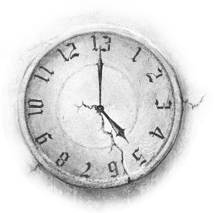

*This card can also just stand for time itself.*

The cold makes life limited. Moving forward is tough, we feel imprisoned.

The repeating rhythm of the metronome is the only dynamics were getting in these times that don't pass fast enough.

Security provides safety and this is the stable foundation we need.

Even the dog is bored of having to walk the same lap around the clock every day.

****+ Moon = it’s your time to shine

+ Ring = permanent contract,

.. a lifelong connection / relationship

+ Dice = never-ending game

+ Well = conservative people

+ Traveller = nomad

+ Sun = endless summer

+ Hive = workaholic, stuck at work

+ Child = due date for birth, forever young

+ Lightning = time-out

+ Lighthouse = binge watching

+ Pie = long-life food, binge eating

+ Library = never-ending story, eternal student

+ Phone = the silent treatment, stop talking

4 Thief

On the card we see an almost invisible thief in a violent snowstorm who is about to take something away from us, only to disappear into thin air again.

Unfortunately, we all have encountered this villain at some point but the realization usually comes too late. Sometimes as a thief, but also in the form of a parasitic friendship.

**Loss, Reduction, To Decrease, Theft, Decay, Little, Scarcity**

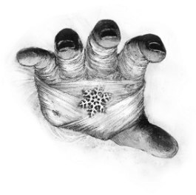

*Unnoticed the thief takes a bit every time*

*or all at once.*

My ‘over-caring’ partner has bad influence, I think he could be a feeder.

From pampering me with treats to overfeeding until I regained control.

Weight loss and stress reduction brought the sun back into my life.



It's still hard accepting myself.

****+ Queen = losing influence / power

+ Heart = lost love

+ Flowers = a trite gift

+ Crossroads = limited free will / choice

+ Past = dehumanised, something forgotten

+ Tree = losing weight or health

+ Key = wasted opportunity

+ Traveller = lack of freedom

+ Sun = depriving someone of joy

+ Coins = lack of money

+ Dog = declining friendship

+ Mermaid = laughing things off

+ Pearl = to downgrade

+ Lighthouse = less vision, eye deteriorating

+ Volcano = reduction of stress

+ Aurora = disbelief, falling fromyour faith

5 Bridge

On this midwinter card we see a broken bridge that prevents you from crossing.

It represents the force working against you.

It stops here or be prepared for serious delays.

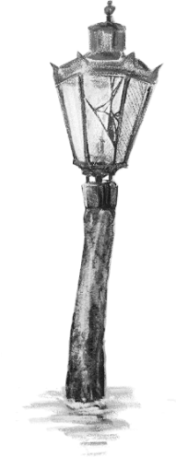Now we feel the obstruction of this

season real good!

**Obstruction, Blockage,**

**Resistance, Error,**

**Damage, Broken,**

**Obstacle, Delay**

*Bridge & Scarecrow*

*in a small spread, row or column*  
*may indicate: the winter of your life*

üüü

This is not ‘water under the bridge’ this

is still an obstruction to move forward.

Damage control is the best we can do to not fall too far behind.

Due to the blue-green algae you cannot swim so you are stranded on the shore.

There is resistance ‘to cross that bridge’ and fix the errors that have been made.

****+ Moon = broken ego

+ Stars = ruined party

+ Tram = cancelled meeting / train

+ Clock = broken beyond repair, total loss

+ Tower = fallen government

+ Ring = broken relationship / contract, divorce

+ Cocoon = miscarriage

+ Coin = damage compensation

+ Harbour = cancelled trip

+ Dog = lost friendship

+ Pie = ruined, a failed dish, spoiled food

+ Phone = inability to speak

+ Ouija = a relapse into addiction

+ Twilight = disturbed peace

+ Aurora = no internet connection

6 Queen

The Queen is a powerful and confident lady. She is extremely impatient and has a very intense and strong personality.

When she enters a room, silence seizes around her. She is overwhelming and intimidating. She knows what she wants and without detours she chases her goals and takes what is hers.

She is not evil, but do not get in her way!

She protects what she owns and always keeps the leashes tight.

**Power, Driven, Intimidating, Egoistic, Distant Person, Clarity, Cold, Egocentric, Oppressive, Solitary*****, S*tubborn,**

*Emotions are just not her thing.*

This queen has no control over snow and ice as written in fairy tales, but she will do everything to stop spring!

The ring of tears gave this ambitious control freak even more strength and perseverance to get it all done. Fast!

Marrying the King gave this opportunist a chance to sit back, relax and delegate.

She once lost everything, but she still stands tall and full of self-confidence.

****+ Moon = claim to fame

+ Snow globe = egocentric

+ Thief = inadequacy

+ Beggar = power relations

+ Tower = dictator, autocrat

+ Heart = cold heart = indifference

+ Äskling P/F = querent, parent , acquaintance

+ Dice = high roller, high-stakes gambler

+ Key = forcing breakthroughs

+ Letter = to do list, assignment list, chore list

+ Wave = shake things up, go against the tide

+ Phone = lecturing, to lecture someone

+ Twilight = the leader resigns

7 Labyrinth

The Labyrinth asks for a solution. But think carefully, because whatever you plan, it will never go perfectly. There are no shortcuts!

Restarting or adapting the current strategy will be necessary. That does not mean failure, it is just part of the process.

You learn by doing, you learn from mistakes.

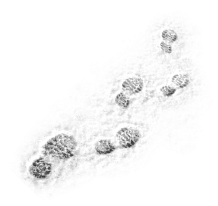**Searching, Strategy, Adapting, Challenge, To Orientate, Researching,**

**Checking Things,**

**Understanding,**

**Insight,**

**Alone**

*The Labyrinth keeps you walking.*

No shortcuts you find on your route. Those hidden setbacks slow you down.

Creativity is needed to overcome the hurdles. Adjust your strategy!



At the exit victory awaits.

Frustrations wander around and it’s visible on you. Learn and find yourself!

****+ Snow globe = vicious circle

+ Clock = closed road, dead end

+ Thief = searching for a lost item

+ Ring = go around in circles

+ Huldra = searching for a scapegoat

+ Future = finding / losing yourself

+ Sun = seeking happiness

+ Coins = geo catching, hunting for treasures

+ Letter = roadmap, walking routes, schedule

+ Mermaid = fishing, solo play

+ Pearl = searching for hidden gems

+ Jelly = hidden flaws

+ Lightning = short cut (s)

+ Library = searching for info, puzzle book

+ Volcano = sensationalism, seeking sensation

+ King = searching for parents

8 Beggar

The beggar is card 8. See the infinity symbol in it, because it represents the situation of a lonely beggar caught in an infinite ∞ loop.

His world is getting colder and people are passing by. He feels invisible because he is ignored and no one looks him in the eye.

It is all about asking for help and receiving help.

**Asking, Questions, Dependency, Equivalence, Lonely**

Is the help really necessary or does it make the other person passive? Maybe dependant?

Is the help genuine? Do you owe someone?

Is it constructive help from the heart to move someone forward. Or is it help for you to show off on social media that you are so committed to the world, to get more likes.

Hunger and cold make someone beg for a good price for the ring. Unfortunately,

the pawnshop does not pay enough.

A nice traveller helps by paying the asking price for this special item.

Many coins mean independence, and this enjoyment lasts all summer long.

In autumn it gets colder and now there is no more money for a necessary coat.

****+ Moon = shelter for the night

+ Stars = feeling left out,

.. not knowing how to participate

+ Tram = asking for a ride (hitchhiking)

+ Heart = a lonely heart

+ Flowers = depending on gifts

+ Wings = asking for a promotion

+ Key = asking for solutions

+ Coin = begging for money / asking for a loan

+ Child = nagging child, a questioning child

+ Pie = asking for food, ordering food / drinks

+ Library = streetwise

+ Ghost = being ignored, depending on charity

+ Aurora = begging for forgiveness

9 Tower

This distant isolated tower is not really inviting and rather cold.

It represents the institution that ensures order, rules and enforcement such as:

the government, town hall, police, army, Court of Justice, tax administration.

They have authority and influence.

The tower is the ruling body and points to regulations, it is intimidating, rigid and business-like. The boundaries are clear.

**Institution, Authority, Regulation, Order, Enforcement,** **Bureaucracy, Politics**

We can also think of institutions such as

airports, hospitals or large companies.

*Here one is addressed in the polite form!*

Mountaineering involves many do's and don'ts and I'm not a docile person.

I love challenges and mountain views so I decided to join the Alpine Institute.

Other climbers pay close attention to the rules. I feel protected and confident.

At high altitude the fear of heights strikes. I freeze against the mountain and am rescued by the army.

****+ Bridge = national lockdown

+ Queen = dictator ship, autocracy

+ Ring = company merger

+ House = government / company office

+ Well = municipal park

+ Traveller = customs

+ Hive = board of directors,a political party

+ Letter = laws, official writings, subpoena

+ Dog = rules must be obeyed

+ Mermaid = political (power) play

+ Jellyfish= governance crisis, judicial dispute

+ Lighthouse = supervisor, overseer

+ Library = school, penal code, lawbook

+ Ouija = being ruled by an addiction

10 Ring

A simple yet elegant ring made of fine wood and gilded with a precious gemstone. It is situated in the cold snow in front of the townhall which indicates the clinical aspect of this agreement.

**Contract, Commitment,**

**Rights and Obligations, Warranty,**

**Assurance, Guarantee, Chains**

It is the glue between things!

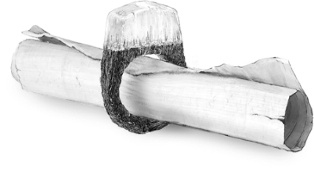

*This ring will bind!*

Feeling chained while you are enlisted in a national service, military conscription or jury duty.

Signing contracts for a new partnership, or maybe an engagement.



Committing into a happy marriage.

The guarantees of the contract bring assurance. You are thankful, faithful and show your loyalty.

****+ Stars = stick to your good intentions

+ Tram = circle / circular bus / tram line

+ Queen = committing to discipline

+ Labyrinth = partner search, dating platform

+ Tower = a chain of business

+ Cocoon = being / feeling chained, imprisoned

+ Crossroads = to compromise

+ House = lease agreement

+ Well = cult, private club, members only

+ Hive = married to your job

+ Harbour = honeymoon

+ Mermaid = Olympic Games

+ Lightning = to pool energy, combine forces

+ Ghost = unbound, untied

11 Heart

This half frozen heart represents all our feelings and emotions.

Feelings of love and hate slow us down because they occupy our thoughts and take up a lot of energy. Therefore they belong to the frozen part of the heart.

While emotions as passion and enthusiasm make us vibrate faster. They belong to the thawed part of the heart that already feels the coming spring.

**Emotions, Passionate, Enthusiasm, Feelings, Love, Hate, Romantic, Disappointment, Compassion**

Love is not easily angered!

*Heart & Traveller*

*in a small spread, row or column*  
*indicate: self-determination*

üüü

The famous gingerbread hearts are funny but very time-consuming to make.

Sometimes worn around the neck to find a partner or used as a marriage proposal.

The brightly coloured hearts are a beautiful souvenir to hang on the wall.

The dough is mostly used for decorative cookies and are seldom eaten. It’s a pity!

****+ Tram = a romantic date

+ Clock = emotional times

+ Thief = love decreases

+ Bridge = heartbroken

+ Huldra = resentful

+ Letter = love letter, hate mail

+ Dog = soulmate

+ Child = enthusiastic child, love child

+ Wave = on/off-relationship

+ Lightning = love crush, heart attack

+ Rose = to cherish, to worship

+ Library = diary, love roman

+ Ghost = compassion

+ Volcano = passionate

+ Aurora = love for God(s) / spirits / deceased

Spring

In week12 the spring starts. On a fine spring morning the cherry blossoms welcome us with flowers everywhere. All other trees and plants are still awakening after winter. The energy starts to flow and everything grows.

We go outside and meet others on a small terrace. It is time for spring cleaning, we open the windows to have the rooms ventilated. We make plans, we start with new things.

*Spring is brimming with energy!*

Here we find the cards that lead us to change and making choices. Good choices are important what brought me to this:

In this booklet you will see that I sometimes use P/F for Äskling of the Past or Future.

Doing the same with M/F for Male & Female doesn't feel right in this day and age.

Thus I decided to use the words: *ALL & Hän*

to indicate that it concerns all humans

regardless of how you identify yourself.

**⸫***The spring moves* ***fast*** *and it answers usually with* ***yes*** *depending on the amount*

*of spring cards in your spread*

A romantic two cardü ü combination story:

*Stars + Well = party people*

*Tram + Past = meeting someone from the past*

Snow globe *+ Pearl = orbiting someone special*

*Clock + Tram = lasting encounter*

*Ring + Pie = wedding cake*

*Heart + Harbour = a honeymoon*

I have said before that it is a creative game of associating. So, I imagine with the example of the Snow globe + Pearl, that someone is twirling like snow around someone very precious in the centre of the Snow globe.

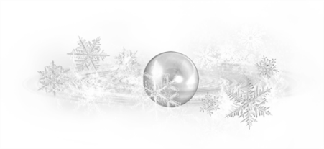

*Do not get carried away in this season*

*where everything seems unlimited.*

12 Flowers

The first card of spring brings us a surprise.

Cherry blossoms bloom very early in the year and in no time they change a wintery landscape into a feast of colour. Suddenly it’s spring, What an unexpected gift!

**Gift, Beauty, Surprise, Appreciation, Suddenly, Hope, Growing and Blossoming**

*Flowers deliver the wow factor!*

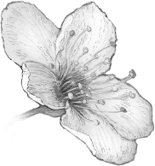

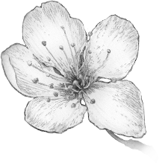

*Flowers & Rose*

*in a small spread, row or column*  
*indicate: balance*

üüü

Unwanted gifts make your house messy and out of decency, you just can't get rid of them so you're stuck with them.

Appreciation for the surprise Easter decoration. Beautiful colours let us rise.

I got a spontaneous thank you and received a luxurious wellness treat.

I cherished picking mushrooms with my friends for our cooking party.

****+ Moon = applause, decoration, ovation,

.. appreciation, valuation, recognition

+ Stars = surprise party

+ Tram = a surprise visit

+ Cocoon = a beautiful transformation

+ Crossroads = an additional option

+ Äskling P/F = beautiful person

+ House = dream house

+ Tree = a beautiful body

+ Well = botanical garden, beautiful park

+ Coins = flourishing business

+ Pie = icing on the cake,

.. birthday / celebration / surprise cake

+ Phone = a beautiful voice, compliment

13 Cocoon   
  
Now spring has really begun and on a strong branch hangs a beautiful cocoon in which a miraculous transformation takes place.

It stands for the completion of something but especially for the phase that follows. When something ends, something new will always take its place.

**Transformation, Healing, Rebirth,** **Growing, Sabbatical, Renewed, Seclusion, Cocooning, To Envelop**

It's about the resurrecting after a temporary absence. We can think of a hospitalization, prison, quarantine or just a good rest in bed.

It is remarkable but the cocoon could also have very small meanings, such as covering something (up) or putting it in a bag.

*Resurrecting after a time out.*

The coin for the shower of the campsite sanitary building gives me just too little time. I feel reborn after my cold scream.

Participating in the holiday pétanque

competition was an elevating time out.

Taking a rest in a hammock in the forest.

I'm past the embarrassment when I walk

back to the sanitary building with a roll of toilet paper under my arm.

****+ Moon = growing confidence

+ Snow globe = trapped in a gilded cage

+ Bridge = cover up defects

+ Ring = renewed contract, strangling contract

+ House = hospital, prison, quarantine

+ Tree = trapped in own body

+ Wings = release, liberated, transformation

+ Well = coming out to everyone

+ Hive = refusal to / seclude from work

+ Letter = renewed translation, rewritten

+ Pearl = retreat = a quiet place to rest

+ Pie = to envelop food, wrap it in something

+ Rain = coming out (transformation outed)

+ Volcano = pent-up anger

14 Huldra

Huldra is a beautiful lady with the tail of a cow and a very seductive smile. She lures you deep into the Kalatian forests, but she can’t be trusted and she doesn’t have your best interest at heart. Trickery and deceit, all of that for her own gain or just for pleasure.

She enjoys the damage she causes to others.

A sexy, intelligent and dangerous lady!

**Deceiving, Manipulative, Seduction**

**Cunning, Dangerous, Malignant, Misleading, Resentful, Gloating,**

**Threat, Retaliation, Rival, Nemesis**

Huldra steals baby’s from humans and

she replaces them with changelings;

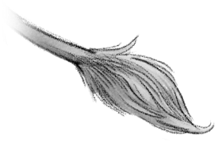 so called: Huldrebarn. A spring-like

interpretation could mean that

Huldra + Child is about adoption.

*Huldra, Mėra, Aura can point to siblings.*

I'm totally overdressed in my puffin feather cloak in this hot botanical garden.

I squeeze myself roughly by the crowd, because I want to know everything about carnivorous plants.

**Fortune favours the bold!** Right!?

**I.e. there’s advantages to being rude.**

Those annoying people call me off.

How dare they.

****+ Moon = keeping up appearances

+ Tram = fare dodger

+ Ring = a trap, fake marriage

+ Flowers = toxic gift

+ Well = the wrong people / environment

+ Traveller = unfair trade

+ Hive = illegal work, undeclared work

+ Coins = blood money, dirty money, bribe

+ Letter = the small or fine print in a contract

+ Pearl = fake values

+ Lighthouse = cast in an unfavourable light

+ Phone = falls flattery, lies, seductive talk,

+ Scarecrow = wanting to cause suffering

+ Volcano = retaliation,envy

15 Crossroads

This card shows a crossroads in a forest where we have the free choice to go left or right.

Every choice has consequences and at this point it is not yet clear what they are.

But one thing is certain…

It is a crossroads and a choice has to be made!

Otherwise, the choice will be made for you.

**Choice, Choices, Decisions,** **Options,**

**In Two Ways, To Duplicate, Multiple, Separation, Walking**

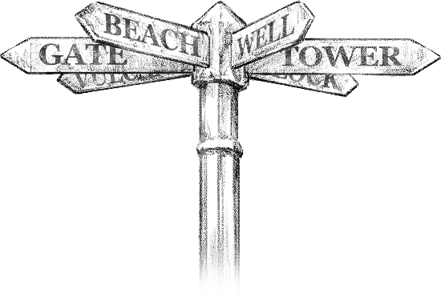

*A different path, or another way?*

Preparations for the Equinox Run are halted because of too many junctions.

An awarded compass has to help the runners by choosing the fastest passage.

Lake Mirkalun offers runners an optional refreshing cooling on the summer route.

Disappointment for those finishing out of time by choosing the wrong paths.

****+ Tram = double date

+ Thief = choice limitation, deduction

+ Ring = separation in a relationship

+ Cocoon = bi / transsexual, genderfluid, etc…

+ Flowers = various advantages

+ Past = dubious past

+ Future = two faced

+ Letter = multiple emails, CC = carbon copy

+ Mermaid = choice-evasive, blithely uncaring

+ Phone = being double tonged

+ Scarecrow = choice regrets

+ Gate = separation anxiety

+ Rain = share a secret

+ Volcano = choice stress

+ Aurora = limbo, oblivion, at the crossing

16 Äskling of the Past

We see a mythical creature, who is half human and half tree. It’s an Ash tree.

In a distant past this English word is derived from the ancient Kalatian word Æskatræ later Äsktrė.

This creature answers questions about the past and future and it’s called an Äskling

Eng: Asking is derived from Ash-ling.

*(noun suffix ending -ling = one connected with)*

This card represents the querent when the question is about the past.

It can also represent anyone else in the querent’s past life.

**The Querent,** The querents past

**A Person,** A person in the querents past life

**History, Old, Old-fashioned,**

**Previous, Ancient, Former**

*This Äskling looks away from things on the right. It has only eyes for things in the past.*

Nothing learned from the past will let you sail against that iceberg once again.

Finding the one true love on the greatest journey of your life was worth the ticket.

The history of the Heart of the Ocean was a wonderful tale that needed to be told.



But we all miss Jack!

*****+* Tram =a missed train / bus / meeting

*+* Snow globe = repetitive past

+ Thief = amnesia, dementia, to forget

+ Ring = the ex-partner, bound person,

.. person is already taken, not open to bind

+ Future = to distrust, sceptical

.. Future = past & present are not connected

+ Well = not open for social life, introvert

.. *The äskling is facing away from society*

+ Harbour = ‘that ship has sailed’

+ Letter = reference, old note, ancient letter

+ Pearl = old values, was once a VIP

+ Ghost = ghost from the past

+ Gate = self-doubt

+ Aurora = fallen **⸫** the angel closes its eyes!

*avers to good advice & far from God.*

17 House

On this card we see a beautiful Kalatian wooden family house. Made from the strongest wood to ensure safety. A protected feeling during every storm. It is a safe haven!

**House, Home, Family, Family Life,**

**The Inner Circle, Privacy, Centre**

Whether you live in a small apartment or in a luxurious manor, here you should be able to be yourself.

.

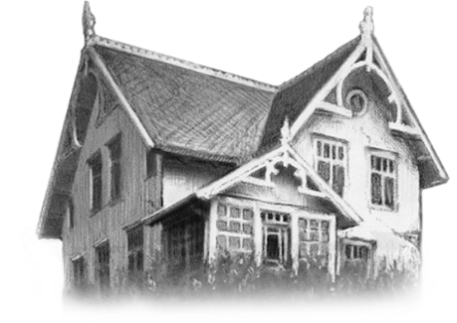

*Everyone who takes their own drink from the fridge belongs to the inner circle.*

The atmosphere is so cold in this house, I feel paralysed in this silent ice palace.

Spring cleaning; it is about opening the windows. A clean house is a clear mind.

Meeting your family at the summerhouse near the shores.

Feeling completely zen chilling with your roommates while smoking a shisha pipe. What a nice evening!

****+ Moon = house decoration

+ Queen = castle, palace, family goals

+ Tower = landlord, housing

+ Flowers = interior designer, housecleaning

+ Past = previous occupant, neighbour

+ Wings = to live together, better house

+ Future = house owner, tenant, neighbour

+ Well = residential area, neighbourhood

+ Coins = household money, fees, rent

+ Harbour = houseboat

+ Dog = family friend

+ Pearl = your home is your castle

+ Pie = home sweet home

+ Ghost = house ghost, poltergeist

18 Wings

These happy moths are flying towards their new home, this fertile rock in the sea.

Our Wings card is card number 18, because at this age you get the right to vote, you can make large purchases and of course drinking and sex is allowed (in many countries)

What an upgrade!!

**Upgrade, Moving,**

**Fertility, Reproduction**

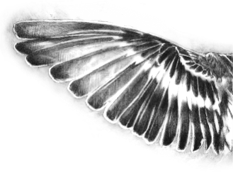This card can also stand for a new home, a or new job, an emigration, a new love. It is the mid-spring card and

it is only positive.

It brings a change

for the better.

*Wings & Mermaid*

*in a small spread, row or column  
indicate: the summer of your life*

üüü

Getting an upgrade to a much larger hotel room, but you lose the sea view.

Your child is spreading theirwings

and moving in their own home.

Because of the raise I can go on a flying holiday with Kalatair this season.

The win of a million brings with it the fear of attracting the wrong people.

****+ Moon = becoming popular / famous

+ Tram = drivers licence, cable car

+ Labyrinth = remote view

+ Crossroads = the easy road, right to vote

+ House = starting or expanding a family,

.. legal age for buying a house, moving

+ Future = broaden my horizon

+ Sun = Icarus, pride comes before a fall

+ Harbour = holiday flight, boat cruise

+ Letter = bucket list, moving notice

+ Child = pregnancy, adoption being granted

+ Jellyfish = dodged a bullet

+ Pie = legal drinking age for alcohol

+ Phone = peptalk, pitch

+ King = gaining wisdom

19 Tree

A Majestic tree adorns this card and it shows the powerful embodiment of mother nature to which we all belong.

The tree therefore also represents our body during our life here on earth. It talks about physical health.

**Body, Health, Earth, Grounding, Life**

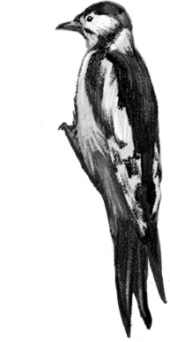The tree is the house in

which our soul lives.

Sometimes we soothe it

with a massage or a

warm bath. Other times

we take medicine or food

supplements to regenerate,

enjoy your chamomile tea

or rub hot oriental oil.

You take care of your body.

*Watch out for the woodpecker,*

*it can indicate pain or surgery.*

A winter cold stops you from going to the gym.

Drinking healthy juices at the May Tree festival to celebrate the earth & fertility.

Showing off your trained body on the beach or just enjoy the mirror image.

You drop your strict sporting regime to take care of your inner self.

****+ Tram = medical encounter

+ Thief = weakening

+ Labyrinth = health check

+ Ring = the annual rings, age

+ Cocoon = body morphing, sleeping

+ House = pedigree, family ties, hospital

+ Letter = doctor’s prescription

+ Mermaid = body positivity

+ Jellyfish = health problems

+ Lightning = medical operation

+ Library = health encyclopaedia

+ Scarecrow = the body that causes mental

.. suffering, e.g. overweight / feeling ugly

+ Rain = body cleansing, sweating

+ Volcano = an inflammation or ulcer

20 Äskling of the Future

This mythical creature, who is half human and half tree, answers questions about the past or questions about the present and future.

The Äskling Cards are the only two cards that can be read in two directions. The side they look at and also the side they look away from.

Therefore they can give us a lot of information.

This card represents the querent when the question is about the present or future.

It can also represent anyone else in the querent’s present or future life.

**The Querent,** The querents present or future

**A Person,** A person in the querents life

**Now, Present, Future,**

**New**, **Next, Upcoming**

*This Äskling looks away from things on the left. It only has eyes for things in the future.*

A Dutch clairvoyant is delivering a deterrent message about a mountain that soon crosses your path.

This upcoming spring break you start a new German language course.



Swiss Summer camp is coming up.

Hoarding Kalatian mountain beer and eagerly awaiting the next Oktoberfest.

****+ Tower = new regulations, new order

+ Ring = new contract, bachelor,

.. single person is free to bind

+ Past = self-reflection, self-focused,

.. embracing the past

+ Well = popular, social, extravert

.. *The äskling is facing towards society*

+ Pearl = is or will be a VIP

+ Jelly = **to foresee a number of problems**

**+** Library = upcoming study, starting a course

+ Ouija = the devil on your shoulder..

.. whispering what to do

+ Volcano = rising irritations / adrenaline

+ Aurora = angel **⸫** the angel opens its eyes! *the attention, guidance & protection of angels*

21 Đice

The card for week 21 is the luck card: Dice.

With 21 dots per die this is no coincidence.

In the game Blackjack, 21 is also the lucky number so with this card we quickly think

of taking a gamble. With the four-leaf clover

located next to your seat you can assume that luck is on your side.

**Gambling, Playing Games, Lottery,**

**Luck, Windfall, Good Fortune,**

**Benefit, Risk, Unpredictable, Unexpected**

A gamble with these lucky dices pays off,

because the odds are in your favour.

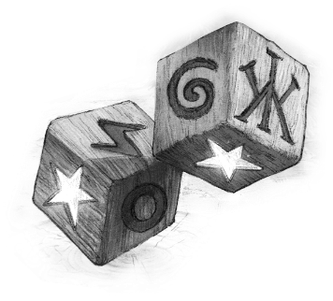The desired result is achieved through a choice or an action that is made.

Take a risk and roll the dice!

During blackjack I say: ‘Hit me’ and a jester gently punches me in the face.

A good fortune cookie tells you to stop gambling and take the money home.

I play it safe and just for fun so I bet on ‘odd’ with faith in the spinning wheel.

All luck comes to an end one day so

Know when to stop! And I didn’t listen.

****+ Tram = free ride

+ Snow globe = probability calculations

+ Thief = luck comes at a price

+ Tower = gambling regulations

+ Crossroads = lucky choice

+ Wings = free upgrade

+ Traveller = a lucky deal

+ Sun = prize won at the fair

+ Coins = flip a coin, gambling, bet for money

+ Letter = lottery ticket, scratch card

+ Dog = greyhound racing, horse racing

+ Lightning = lucky strike

+ Lighthouse = lucky sign, good omen

+ Ouija = risky social media - challenges

+ Aurora = miracles

22 Ꝁey

Shown on this card is a key that seems to mean that it can open and close doors and other things. This is certainly true, but the light that shines from behind the door shows that this key can set much more in motion.

**Make, Create, Activate, Initiative,**

**Innovate, Improve, Inventive**, **Breakthrough, Answer, Open and Close, Testing Out, Solutions, Production**

This is an active card full of ideas and possibilities to the take the initiative to make or adjusting things. The key is in your hands!

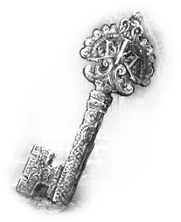

*The key finds lost affairs.*

****Locking yourself in your house as you have nothing to wear for the winter gala.

Starting crowdfunding for your own clothing creations.

You feel free to wear whatever you want for strolling down the boulevard.

Afraid to criticize the emperor’s new clothes making him feel very foolish.

****+ Clock = reset, adjust, turn back time

+ Bridge = repair, overcome hurdles

+ Labyrinth = short cut, right strategy

+ Huldra = making / creating forgery

+ Wings = to set free, to let go

+ Well = open accessible to the public

+ Sun = breakthrough, key to success

+ Coins = safe (to lock away money)

+ Letter = draw up a plan, take notes

+ Pearl = be privileged, key position

+ Pie = making a sandwich / coffee

+ Library = locked book, diary, privacy

+ Gate = driven by fear

+ Volcano = Pandora’s box, unleash emotions

+ Aurora = manifest desires

23 Well

On a beautiful green plain there is a well where you can get fresh water but much more importantly, at the well we meet other people for a nice chat, to make new contacts.

You can meet people in a park or at a public garden, maybe on a nice spring festival. The well is a social place.

**Socializing, Meetings, Social Media, Area**

Do you like to meet people at your swimming club, or your walking group. Or re-join in a restaurant for a birthday or a family reunion.

Sometimes social encounters can also be a little less light hearted in nature, such as:

funeral / church services, demonstrations.

*The well is a club of freethinkers*

*Ember Pie is a group of friends*

*The hive is a collective thinking as one.*

I want to practice and do my swimming laps, but the children keep jumping in.

The group lessons and my dedication got me my first swimming diploma.

Enjoying this beautiful sunny day at the pool with friends and ice-cream.

I’m disappointed because the number of students for the diving course is too low.

****+ Snow globe = people in your bubble

+ Thief = losing people

+ Cocoon = social isolation

+ Past = missing social life / old friends

.. *The äskling is facing towards its social past*

+ Future = left people behind, no group type

.. *The äskling is facing away from its social past*

+ Traveller = a group of travellers

+ Sun = visitors of weekly market, spectators.. .. at a parade, participants at a celebration

+ Hive = team meeting

+ Dog = philanthrope, peoples person

+ Pie = group lunch, team dinner

+ Gate = agoraphobia = public places fear

+ Rain = public revelations

24 Traveller

There in the distance the traveller comes around the corner. This elusive loner has gathered curios and tales. Everything is for sale or to be bartered.

**Free Soul, Independent, Merchant, Collector, Loner,** **Nomad, Trading, Listener, Storyteller, Artistic,**

**Entrepreneur,** **Freedom**

This restless, free soul usually

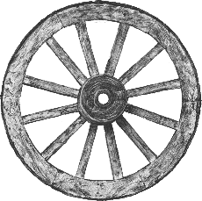stays a few moons before

travelling on indefinitely.

A reunion is certain.

*Do not keep travellers from travelling!*

*Traveller & Heart*

*in a small spread, row or column*  
*may indicate: self-determination*

üüü

Because of the contact restrictions the merchant has to stop trading.

Relocating now with this perfect tiny home on wheels is therefore a good idea.

Celebrating the return of freedom by making music or listening to the tales from the like-minded around the fire.

Worries about losing revenue due to too many customers and not enough supply.

****+ Thief = to haggle, to bargain

+ Heart = restless heart

+ Cocoon = hermit, loner

+ House = trailer, caravan, travellers wagon

+ Well = traveller community, nomadic tribe

+ Sun = funfair, carnival, festival, circus

+ Hive = sole trader, entrepreneur

+ Coins = pawn shop, mobile shop, market stall

+ Letter = newspaper, door-to-door magazine

+ Dog = stray dog, bohemian friends

+ Pearl = collector of valuable goods

+ Pie = charity bake sale

+ Library = collector of books / comics, literary

+ Ghost = to foretell, a seer / clairvoyant

Summer

Week 25 means the beginning of summer, it starts with the ‘Midsommar-sun’.

The temperature rises. We indulge the sun, the sea, the beach and the light on the longest days of the year.

We enjoy barbeques on warm summer afternoons. Doing nothing! Maybe soon we do even less when heatwaves become common. The summer is that season when you can enjoy and laze around. Life is good!

*The Summer is long, lazy enjoyment!*

Most of us sense a less outgoing productive energy. It comes from inside us. We enjoy to take it a bit slow and there is nothing wrong with that. We recharge our battery and we feel comfortable in our own body.

Cheerfulness in an endless summer. Watch out for sunburn! Wear a sunscreen with at least a protection factor 30!

**⸫***The summer moves* ***slow*** *and it answers usually with* ***yes*** *depending on the amount*

*of summer cards in your spread*

After the nice midsummer weeks the structure and focus returns, this is reflected in the cards. The atmosphere changes, which is not so bad at all. Who are we and what are our goals?

Let’s take a look at a three-card ü ü ü spread:

*Question: Where can I find a job?*

*Answer: Sun + house + well*

*sun + house = summerhouse*

*house + well = housing area/park*

*So, the answer can be: at a holiday park*

The cards give a very clear answer and that sounds like a really nice job.

25 Sun

This bright card represents the week with the year’s longest day: the Summer Solstice.

Aside from this immense positive energy, it can also signify the happy Midsummer night celebration. On this longest day of the year we enjoy the sun by dancing all night.

**Illuminating, Optimism, Success, Celebrating, Enthusiasm, Positive, Festivity, Revelation, Welcoming, Victory**

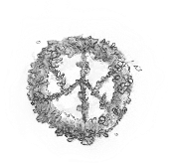

*Sun & Moon*

*in a small spread, row or column*   
*may indicate: polarisation*

üüü

****This infamous restaurant is known for its cold service, but I am enthusiastic!

It’s an: ‘All you can eat restaurant’ and I will start optimistically with a gazpacho.

I was able to rescue a lucky fly from my cold summer soup. I felt victorious!

Do not fly too high, Icarus! You over-confident fly. Pride becomes for the fall.

****+ Clock = day time, happy ever after

+ Past = a good past

+ House = a nice house, warm family ties

+ Tree = a healthy or fit body

+ Future = optimist, a bright future

+ Harbour = summer holiday

+ Letter = festival tickets, good news..

.. invitation, welcoming letter, thank-you note

+ Mermaid = fun - activity, sunbathing

+ Wave = summer daytrips, swimming,

.. theme park, funfair rides, bungee jump

+ Lightning = positive energy

+ Pie = summer cocktail, good meal

+ Phone = a nice, friendly voice, laughing

+ King = Thanksgiving, gratitude

26 Hive

Bees are very active and hard workers and that is why there is one depicted on the card. This bee represents work and career.

Having an nice job and a collaboration with fine colleagues is rewarding, it brings stability.

The queen bee indicates the hierarchy of the networking structure.

**Work, Colleagues, Collective, Hierarchy**

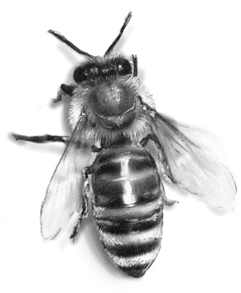

*The hive is a collective thinking as one*

*The well is a club of freethinkers*

*Ember Pie is a group of friends.*

****This assembly line work at the herring factory is dull and monotonous.

Starting a collaboration to improve the working atmosphere and team spirit.

Having the most enjoyable company outing to a bee yard with your colleagues.



Satisfaction in your job.

****+ Moon = working in the..

.. entertainment industry, tv, theatre

+ Clock = working late, overtime

+ Bridge = career stop

+ Crossroads = working part-time

+ Wings = work promotion

+ Well = conferences, seminars,

.. work colleagues, affiliate with a commune

+ Coins = wages

+ Letter = work schedule

+ Wave = working in shifts

+ Lightning = burn-out

+ Library = job education

+ Phone = work consultation, job interview

+ Volcano = work stress

+ Twilight = sabbatical

27 Coins

This card shows the abundance of grain, salt and coins coming out of an ancient magic machine that was found in a shipwreck just off the Danish coast.

The gears represent the running economy.

The grain and salt represent goods and trade.

The coins represent cash and money traffic.

**Money, Wealth, Abundance,**

**Value, Finance, Income,**

**Turnover and Profit,**

**Shops, Enterprise**

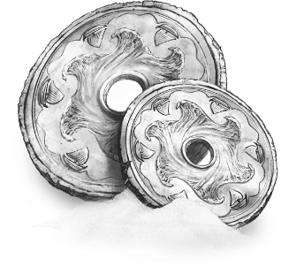

A tram strike on shopping night; walking will cost me hours of shopping fun.

I rush into the stores to make up for lost time and take advantage of all the offers.

At closing time there is extra discount and I buy more than I can carry home.

I meet friends who walk home with me and without a tram we even save more.

****+ Stars = growing wealth

+ Queen = shopping queen (ALL)

+ Beggar = poverty

+ Future = money worker, banker, investor

+ Dice = discount

+ Key = money opens doors

+ Traveller = bitcoin-trader, coin collector

+ Letter = stocks, securities

+ Jellyfish = money problems

+ Rose = financial heritage

+ Library = cashbook

+ Ghost = charity, money donation

+ Gate = economic uncertainties

+ Rain = financial transparency

+ King = sparsity

28 Harbour

A ship leaving the King’s Gate harbour stands for a physical movement across borders with the use of any means of transportation.

The most likely is a ship or an airship such as a zeppelin or a plane and let's not forget the long-distance buses. Everything is possible as long as it's outside your area / region.

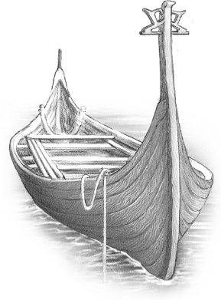**Travelling, Transport, Movement, Distance, Departure, Foreign,**

**Expedition, Exploring,**

**Emigrating**

*Coming by tram, leaving by boat.*

 Sailing the 7 seas during this cruise only brings me seasickness. Will it ever end?

Every day we board new harbours and discover new cities. Life is a gift!

Delighted to be invited to the captain’s table for dinner in the grand ballroom.

I feel separated from the other guests because my cabin is next to the running engines. The noise is driving me crazy.

****+ Tram = Orient Express, airport-train

+ Clock = departure time

+ Tower = airport, travel agency,

.. harbour, immigration authorities, asylum

+ Äskling P/F = foreigner, travel companion,

.. travel agent, customs officer, crewmember

+ House = the journey home

+ Wings = emigration, world trip

+ Letter = travel voucher, boarding pass,

+ Mermaid = foreign sports tournament

+ Phone = announcer voice, foreign language

+ Gate = hodophobia = travel fear

+ Volcano = travel stress

+ Aurora = journey to the afterlife, pilgrimage

29 Letter

A message in a bottle is a very efficient way of communicating, but this card also stands for e-mails, letters, messages and memos.

All written communication falls under this card, including packages as they are the result of an order form.

**Letter, E-mail, Invitation, Order Form, Packages, Tickets, Flyers, Advertising**

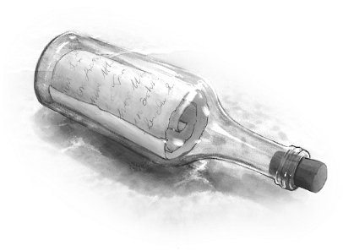

*The written word covers*

*all meanings of the letter.*



A diners broken drive-thru order kiosk.

Ordering inside on the self-service kiosk is fast and convenient, the choice is huge.

Before my receipt comes I keep getting extra offers that I buy.

Guilt that I ate so much and only on the tray flyer do I read how many Kcal it was.

****+ Tram = post deliverer, courier

+ Tower = post office

+ Ring = written contract

+ Huldra = the small letters

+ Past = scrolls, parchment rolls

+ Tree = results of medical check up

+ Key = letter of authorization, written answer

+ Sun = permit, license, authorisation

+ Coins = paper money, banknotes,

.. bank statement / account, tax returns

+ Dog = pen pal, text message to a friend

+ Pie = food label

+ Phone = fax, SMS, text message

+ Twilight = drafting a will, memoirs,

.. letter of resignation

30 Đog

‘A dog is a man's best friend’ were the true words of King Frederick, a wise king from earlier times.

I totally agree with that and that's why I pictured our dog Tala on this summer card, playing on the beach near the North Sea.

The main meaning of this card is friendship;

whether it's the friendship between people or the friendship we have with our pets.

 **Friendship, Loyalty, Trust,** **Unconditionally,**

**Dog, Pets, Pet- child,**

**Following, Participate,**

**Obedient, Docile, Brave,**

 **Protective, Frisky**

*A true friend is always good company!*

****Dog training takes time and when the puppy adolescence comes, it seems that everything is forgotten.

Fetching a ball is fun! It's a good interplay and strengthens the bond.

When we're both tired of playing, we cuddle on the couch and eat goodies.

In case of fireworks or thunderstorms, our dog is afraid and I offer protection.

****+ Tram = a friend comes to visit

+ Snow globe = running in circles,

.. friendzone, woofing all around

+ Beggar = man’s best friend

+ House = breeder, animal shelter

+ Well = bandwagon effect = follow the crowd

+ Coins = pet store, dog tax

+ Lighthouse = vigilant, alertness

+ Pie = to grovel, dog-hungry, craving

+ Phone = confidential conversation

+ Ghost = imaginary or passed away friend,

.. very good instinct, can sense people

+ Volcano = barking as warning, protecting

+ Twilight = friends at last, friends till the end

31 Mermaid

On this Midsummer card we see Mėra.

She is half woman, half seahorse and happily swimming in the water. Carefree and enjoying life like there is no tomorrow. She sings along with the song of the sea, she feels fantastic!

**Careless, Playful, Sporty, Unpretentious, Healthy, Impulsive, Striking,**

**Lightness, Eccentric, Self-willed**

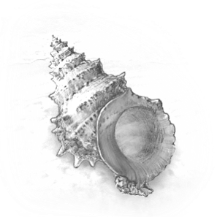

*Mermaid & Wings*

*in a small spread, row or column*  
*may indicate: the summer of your life*

üüü

The Zumba instructor teaches us moves that are way too difficult. It’s hard for me so I just do my own steps.

Playful beats sound as we continue our healthy work-out. I feel fit and fantastic!

Nice to replenish your burned calories with an abundance of delicious blueberry cheesecake protein shakes.

The dance on the song of the sea make me long for the rhythm of yesteryear.

****+ Thief = the laughter will perish you

+ Labyrinth = to slip through the net

+ Tower = resistance to hierarchy

+ Tree = feel good about yourself,

.. comfortable in your own skin

+ Well = gym, fitness centre, sports club

+ Dog = playful dog / friend

+ Wave = go with the flow,adapting

+ Pie = healthy food, nutrition diet

+ Phone = bla bla bla whatever lalala, singing

+ Ghost = Looking away from difficulties

+ Scarecrow = song of the sea **=** melancholy

+ King = a self-regulated person

32 Child

On the beach a special child plays with a piece of wood. It descends from the forest, where she originates from. This girl is a huldrebarn, a changeling, a foundling, but above all a perfect child. Her name is Lorelei.

This card reminds us that children are special, pure and innocent no matter how they look or where they come from.

**Child, Children, Childish,**

**Disobedient, Teenager, Rebellious,**

**Pure, Innocent,**

**Naive, Fantasy**, **Boundaries, Vulnerable**

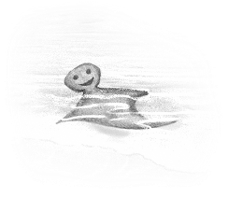

Potty training is not very successful and the bed-wetting causes a lot of work.

Reading fairy-tales aloud visibly helps the child's imagination and development.



The toddlers ‘No-Stage’ is entertaining.

Learning by socializing with other kids,

caring and sharing, testing limits.

****+ Moon = youthful appearance,

.. childhood dream, child performance

+ Snow globe = fantasy world

+ Cocoon = being pregnant, incubator

+ Huldra = child abuse, attachment disorder

+ House = doll's house, safe place

+ Dice = board games, playing, child play

+ Well = playground, playing field, play area

+ Traveller = face painting tent, puppet show

+ Sun = baby shower, welcoming a child, birth

+ Hive = child labour, children's day care job

+ Coins = child benefits, pocket money

+ Dog = a puppy, a stuffed animal

+ Pie = lemonade, candy, milk and cookies

+ Library = children’s book, fairy tale story

+ Scarecrow = childhood trauma

33 Pearl

The chance of finding a valuable pearl in an oyster is rare, but if you are the type that can wear pearls you will rise in people’s esteem.

Your words and deeds gain importance and influence.

**Status, Influence, Rising, Royalty, Exclusive,** **Self-confidence, Fashion, Upgrade, Style Values**

Pearls can lift everything to a higher value!

A pearl can stand for a person, a certain idea, a religion, moments, materials or an object.

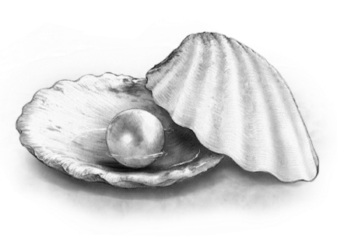

*For some, pearls are a great burden to bear**.*

****The reputation of a singer is waning as

a vocal cord polyp ends hän concert tour.

The self-value rises after taking singing courses by a highly regarded vocal coach.

Elegant and full of self-confidence hän appears on the red carpet of a music gala.

Despite some false notes this vocalist nervously takes stage again.

****+ Moon = pride, jewels

+ Stars = big intentions

+ Flowers = status-enhancing

+ Past = antique goods

+ Key = skeleton key, key card, trump card

+ Hive = important job, conductor function

+ Coins = a valuable coin, strong currency

+ Letter = important documents

+ Mermaid = jet set life, luxury living

+ Child = the favourite one (child)

+ Pie = precious moments, luxury food,

.. icing on the cake = unexpected extra / bonus

+ Library = valuable information

+ Rain = falling from grace

+ Volcano = power struggle

34 Wave

Slowly we are moving towards the end of summer. Lazing and enjoying soon will be over. Then comes the wave!

The wave brings more motion and variety. It is an activating card, not good or bad. It just gives more dynamics, and you might have to get used to that.

**Variety, Dynamics, Acceleration, Repetitive, Keeping Balance, Fluctuating, Resilience, Disarray, Drifting**

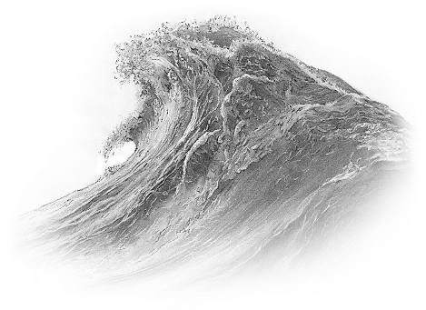

*The wave is about movements,*

*up & down, from left to right.*

****Rude people who skip in line at the funfair park and you don't dare to say anything so now you have to wait longer.

The new high speed rollercoaster brings us in no time to the end station again.

The Ferris wheel is going slow, but you love the wonderful sunset panorama.

I came out of the dark haunted house trembling on my legs in fear.

****+ Tram = shuttle bus / train, elevator

+ Clock = metronome, alarm clock

+ Queen = drama queen (ALL)

+ Ring = variable contract (energy)

+ Äskling P/F = disorderly person

+ Tree = shaky, spasm, wobbly

+ Well = vibrant place

+ Child = a busy child, rocking a baby / child

+ Pearl = balancing priorities,

.. valuing something, weigh on a scale

+ Pie = variety in food & drinks

+ Scarecrow = the waves of grieve

+ Gate = wave of emotions, mood swings

+ Volcano = recurring rage attacks

35 Jellyfish

The colours of this jellyfish are mesmerizing, but be aware! Encountering it while swimming, poses a real problem.

If you see this creature then you better take action and swim around it or get out of the water. If you don’t see it, then there will be consequences.

**Problem, Difficulties, Awareness,**

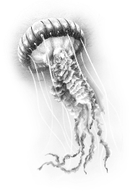**Action, Challenges,**

**Infection, Rash,**

**Complaints,**

**Poison**

The deadly nightshade keeps coming back in my vegetable garden.

What a terrible stench but the vegetables love the biological fertilizer.

It is raining way too hard for gardening, but it’s nice that the plants grow quickly.

A herbicide infection, rashes, stench; gardening is a bummer and the poisonous belladonna plant blossoms.

****+ Moon = negative appearance

+ Tram = unpleasant encounter

+ Clock = bad times

+ Bridge = a bad link, bad connection

+ Labyrinth = being on the wrong track

+ Crossroads = choosing between two evils

+ Past = problems of the past

+ Dice = bad luck

+ Well = a bad environment, the wrong place

**+** Sun = problem with the sun, sunburned

+ Lighthouse = disaster is in the air

+ Pie = famine, food allergies / poisoning

+ Phone = complaining, nagging

+ Rain = painful truth, challenging reality

36 Lightning

An ominous sky gathers at the end of a sweltering summer day. The hot air is oppressive. Totally unexpected and with an unprecedented force lightning struck and it could almost split the sea in two.

This card is about a quick division of things.

**Immediate, Division, Splitting, Ending, Electricity, Fast, Energy, Force, Dividing, Spontaneous, Irrevocable**

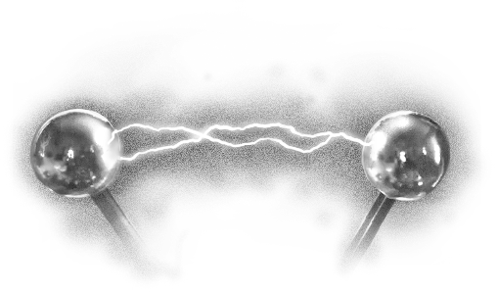

*The speed of this card is striking.*

The wrong size bowling shoes are killing my chances of winning.

With immense force I hit the pins for a perfect strike. Bammm!

I feel so comfortable with my lucky bowling ball, I’m taking the win home!

A jolt of pain in my feet at being down 30 pins, forced me to quit unexpectedly.

****+ Tram = high speed trains, maglev

+ Queen = forcibly coercing

+ Ring = sudden / unexpected proposal

+ Flowers = pruning, gardening

+ Tree = jolt of pain, cut, operation, fainting

+ Coins = divide the money, split the money

+ Letter = tearing up a letter

+ Dog = unfriending, biting dog

+ Rose = being pricked by thorns / sharp thing

+ Pie = intermittent fasting, cutting food,

.. to fast - Ramadan, no alcohol in Dry January

+ Phone = to swear, curse, insults,

.. truncate a conversation

+ Ouija = quitting an addiction

+ Volcano = to have a short fuse, violence

37 Lighthouse

The Lighthouse at the end of summer let his light shine forth to provide a safe haven to some and direct others the right way.

The revolving light may also be looking for you, so remember to keep yourself out of the limelight.

**Beacon, Navigation, Guiding, Orienting, Watching, Seeing, Scanning, Observer,**

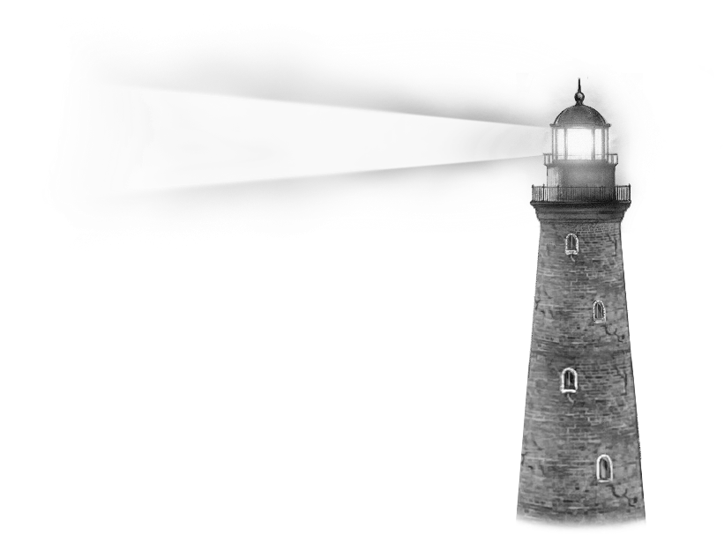**To Perceive, It Warns**

*Lighthouse & Aurora*

*in a small spread, row or column*  
*indicate: spiritually guided*

üüü

The supermarket freezer department is out of order and I really needed instant food. Just my luck!

The direction arrows in the aisles guide me to the bulk-section.

The microwave ready meals enlighten my day. Let’s go for an easy week.

The end price on my receipt was a warning to pay more attention next time.

****+ Labyrinth = a safe passage

+ Tower = isolated

+ Crossroads = signpost

+ Future = a civil servant indicating direction

+ Coins = to test the authenticity of banknotes

+ Harbour = the end of a journey

+ Dog = alertness, vigilance,

.. scanning the surroundings

+ Pearl = it’s lonely at the top

+ Wave = scanning the assortment

+ Lightning = stand tall and face the storm

+ Phone = air raid alarm (revolving sound)

+ King = beacon of tranquillity

+ Aurora = browsing the internet

Autumn

After a nice, long and lazy summer we have arrived in autumn. This is a season where the energy is flowing again and this time, it is directed inwards.

We had good intentions with Sylvester, in the spring we shaped our ideas, in the summer we reaped the benefits of our labour and now on a rainy autumn evening we evaluate.

What results have we achieved and what do we think of them? Where do we stand and how does that feel?

*The autumn lets us meet ourselves!*

It is important to process, learn and prepare

The weather is getting bleaker and we buy tasty things for cosy evenings. Candles are lit and we find ourselves.

The psyche experiences a great influence at this time of year.Unfortunately also shame, regret, depression and mourning are a part of this. Yet, that does not mean all hope is gone.

**⸫***The autumn moves* ***fast*** *and it answers usually with* ***no*** *depending on the amount*

*of autumn cards in your spread*

It is never only good or bad.

On beautiful autumn days when the sun turns everything into gold, we go outside.

We get the chance in autumn to process, learn and get to know ourselves better.

ü ü ü a nine-card spread is my most used

ü ü ü spread because it gives so much

ü ü ü information in the different directions of reading, and the rows and columns can have their own season or location influences

A dominating season is clearly visible in this spread, if more than half of the cards are from

one season. The more cards from one season, the stronger their influence is.

*Example: Even a spread with 6 out of 9 cards in autumn could still end very happy and cheerful*

*when it has three cards of summer in the future.*

*More info about spreads from page 122.*

38 Rose

The first card of autumn is a rose preserved under a fragile dome held together by thorns.

If we look through the cracks in the glass we see an illusion of something beautiful that once was.

**To Cherish, Preserve, Releasing, Conservative, Worship,** **To Honour**, **Impermanence, Consolation**

This conservative card asks the fair question: hold on or let go? The thorns might hint at the consequences of that choice.

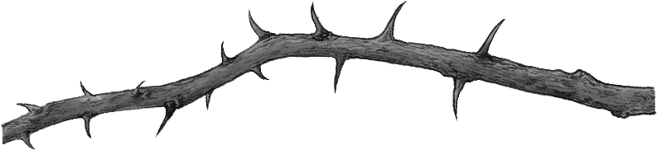

*Rose & Flowers*

*in a small spread, row or column*  
*may indicate: balance*

üüü

Based on their conviction, grandparents do not agree with the choice of partner.

What would the neighbours think!?

Sticking to good old values & traditions.

That's the way they were raised.

Viewing photo books from the past,

life was better in the good old days!

Melancholy is a beautiful sting.

Resentment & hatred is self-flagellation.

****+ Snow globe = live by traditional value

+ Tower = in the name of the law

+ Ring = divorce or till death do us part

+ Huldra = an **eye** **for** **an** **eye**, a tooth…

+ Past = letting go, releasing, forgiving

+ Future = holding on, preserve

+ Letter = memo note

+ Pearl = moral knight, dated values

+ Pie = not wanting to share *‘your precious pie’*

*..* not wanting to outsource something

+ Library = living by to the book

+ Scarecrow = to mourn, letting go of burdens

+ Rain = confess, forgiveness by 10 hail Marys

+ Aurora = living by the 10 Commandments

39 Ember Pie

We see a cosy room with a delicious ember pie and there’s plenty to share.

This card is about your social life. Meeting friends, enjoying food and drinks, preparing and hoarding for the coming winter.

**Consuming, Hoarding, Connecting,** **Selfcare, Enjoyment, Recharge,**

**Gathering, Boardgames, Reunite**

The weather is changing and were going back inside, both physically and mentally.

Cosy under a blanket on the couch with hot

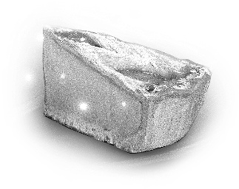 chocolate and a nice

big piece of

ember pie,

we find enough

energy to make

great new plans.

*Ember Pie is a group of friends*

*The well is a club of freethinkers*

*The hive is a collective thinking as one.*

The film crew gathered to hear that it will not give a sequel.

Toasting on the enjoyment of hearing that a second chance is given.

Reuniting with the entire cast to celebrate the last day of shooting.

A down casted mood as the movie has received a lot of rotten tomatoes.

 + Tram = drinks being served

+ Tower = restaurant, discothèque

+ Cocoon = hoarding, prepping

+ House = kitchen, candy house,

.. welcoming pie (for the new neighbours)

+ Dice = beer / drinking games

+ Traveller = ice-cream van

+ Sun = food festival, fair

+ Harbour = culinary journey

+ Letter = shopping list, recipe

+ Dog = connecting / dinner with friends

+ Wave = a tasting getaway

+ Library = cooking book

+ Phone = dinner invitation

+ Scarecrow = eating disorders

40 Library

The Royal Library displays an open book containing all kinds of information.

Here in this pleasant room one can gather wisdom for hours.

The library card means acquiring knowledge, studying and learning. Via books, classes, online or by other means.

**Education, Knowledge, Knowing, Understanding, Findings**

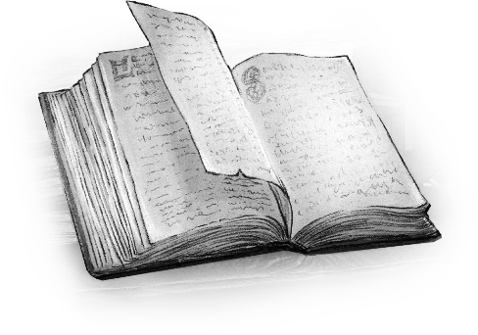

*Gathering knowledge covers*

*all meanings of the library.*

An overcrowded book fair means that a lot of haggling will be difficult.

Reading is fundamental, so motivated

I look for books on my wish list.

I find everything for fair prices and also come across surprising books about dice.

I've learned how to close myself off from the crowd and I'm going to the exit.

****+ Stars = diploma celebration / party

+ Labyrinth = knowing where to search

+ Past = old books, ancient history

+ Dice = an educated guess

+ Key = learning by doing

+ Well = a study group

+ Traveller = bookstall on a book market

+ Letter = diploma, charter

+ Rose = intellectual legacy

+ Pie = study gathering, school reunion

+ Ouija = understanding your pitfalls

+ Rain = plot of a book

+ Twilight = finally understanding it

+ Aurora = info everywhere = internet

41 Phone

A beautiful old telephone is central on the table. A glass of wine indicates a good conversation or light-hearted gossip that is about to take place.

This card can also represent an interview, discussion or conference.

**Communication, Conversations, Discussions, Gossip**

**Small Talk, Talking, Listening**

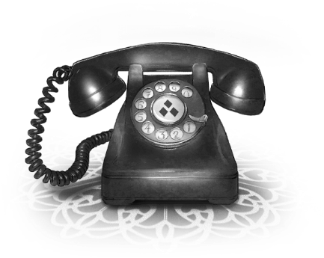

*The spoken word covers*

*all meanings of the phone.*

The whistle blows and the umpire shows the red card. No discussions possible.

Negotiations have been a success. I give interviews introducing my new team.

My captain unveils his plans for the new season. First a merited summer break.

******The chants from the hooligans hurt me more than I want to admit.

****+ Snow globe = talk to like-minded..

.. people in your bubble = echo chamber

+ Bridge = being on non-speaking terms

+ Labyrinth = telling riddles, speak in riddles

+ Ring = oral contract, pledge, promise

+ Huldra = gossip, rumours

+ Key = spoken answer

+ Well = the voice of the people = democracy

+ Letter = voicemail

+ Child = telling jokes, child speak

+ Wave = chanting, singing, recite a poem

+ Jellyfish = communication problems

+ Rose = a sermon on self-determination

+ Rain = speaking your mind, talking bluntly

+ Volcano = a voice that irritates

42 Ghost

Aura is not being heard or seen. She is a friendly caring lady, but no one seems to notice her presence.

She tries her best to be appreciated by always being there for everyone and whispering good advice in someone’s ear.

Self-effacing for others is second nature to her and she takes her loneliness for granted for the sake of others.

**Intuitive, Spirit, Unnoticed, Caring, Guiding, Shielding, The Deceased, Solitude, Selfless, Serving, Compassion**

How we experience the presence of spirits varies from person to person.

I get goosebumps when I’m being touched as confirmation to the words I speak. Maybe you experience a comforting presence. Just try and find the answers in the silence of your head.

Spirits are helping when we see patterns in the ice crystals on the winter windows.



Spring butterflies guide us on our way.



Hearing voices in the winds of summer.



Or by reading autumn blend coffee cups.

****+ Moon = giving appreciation

+ Snow globe = false certainty

+ Bridge = hidden flaws

+ Labyrinth = disappear without a trace

+ Beggar = giving consolation, empathy

+ Ring = empty promises

+ Heart = being numb

+ House = ghost house

+ Well = charity, caring for the community

+ Hive = assembly line work on autopilot

+ Dog = imaginary friend

+ Pearl = having no prestige

+ Lighthouse = being clairvoyant

+ Phone = EVP - electronic voice phenomena,

.. empty words, unanswered, whispering

+ Volcano = dodging, conflict-shy

+ Twilight = give your mind a rest, meditate

+ Aurora = vanish into thin air, ghosting

43 Ouija

Oui / Ja, yes! That is the answer we want

to hear to our questions, but looking for answers in the wrong place is never wise!

Hoping you can solve your money problems by hitting the jackpot in the casino? Or you want to lose weight by sticking your finger down your throat?

This card is about self-sabotage. You are looking for solutions in the wrong places and in the wrong way, and you know it!!

**Self-Sabotage, Insidious, Yes - False Info**

There is always a self-interest that outweighs your common sense.

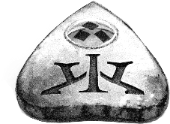

*Oui, Ja, Yes,*

*It’s the devil whispering in your ear.*

Visiting a circus while afraid of clowns is dumb, you know you shouldn't!

Aerial acrobatics without a safety net is extra exciting. You will be entertained.

Magic mushrooms make this circus tent spin like an insane carousel. So nice!

A bad trip makes you so sad that you cry over cotton candy.

****+ Bridge = self- destruction

+ Cocoon = sleeping problems away

+ Huldra = sex addiction

+ Dice = gambling addiction, dangerous play

+ Hive = excessive work for distraction

+ Jellyfish = dealing with toxic people / poison

+ Lightning = inviting the wrong energy

+ Pie = comfort food, drowning your sorrows,

.. unwanted guest that you consciously let in

+ Library = reading dangerous banned books

+ Phone = the devil’s advocate..

.. provoke with your opinion to test others

+ Rain = looking away & ignoring the truth

+ Volcano = looking for conflicts / fights

+ Aurora = going on the deep web / dark web

44 Scarecrow

Each deck has a card you’d rather not see in a reading and in week 44 we meet the Scarecrow. On this mid-autumn card we see someone who seems free to leave this dark place behind, but traumas, regrets and suffering prevent hän from moving on.

**Traumas, Regrets, Mourning, Suffering, Burdens, Shame, Depressions, Remorse, Exhaustion, Sorrow, Mentally Ill**

The crows represent the burdens and sorrow

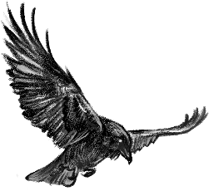 hän carries from the past that still plague

hän. Some are permanent scars.

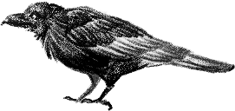

*Scarecrow & Bridge*

*in a small spread, row or column*  
*may indicate: the winter of your life*

üüü

Doors that remain closed won't give you candy this Halloween.

Trick or treat? The "trick" refers to

a threat to perform mischief on the residents and this threat yields treats.

The dead walk the earth during the night of All Hallows’ Eve.

You want to grieve in order to give value to the one you have lost.

****+ Stars = holiday associated trauma

+ Tram = xenophobia, fear of strangers

+ Snow globe = PTSD / PTSS

+ Thief = trauma release

+ Bridge = permanent scars, soul damage

+ Queen = narcissistic stare to control you

+ Heart = lovesickness, a broken heart

+ House = mental home

+ Key = psychic therapy

+ Lightning = doomsday thinking, trigger

+ Rose = this burden is too heavy to carry

+ Library = information processing disorder

+ Twilight = EMDR, reset, process & recover

45 Gate

The Gate card shows an old portal. Outside an ominous mist makes everything look menacing. Inside it is cold, dark and damp. Unsure to go out or stay inside, because neither options seem very appealing.

**Confused, Insecure, Doubt, Distrust Worrying Thoughts, Delusional, Ignorance, Fear, Sinister**

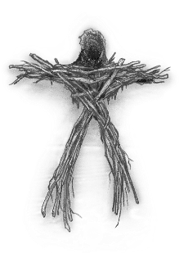

*Fear is a bad counsellor.*

The athlete is in doubt. This injury forces a withdrawment from the Olympic qualification tournament.

A dilemma arises. Temporary taking steroids brightens the Olympic chances.

Without any remorse the biggest throw of hän career brings the gold medal.

The fears becomes real for the confused athlete as the tests are positive on doping.

****+ Moon = nightmare, scary dreams

+ Labyrinth = dilemmas

+ Beggar = fear of existence

+ Ring = fear of commitment

+ Huldra = hesitation to give in to temptation

+ Wings = fear of heights, climbing ladders

+ Future = uncertain present / future

+ Well = scary / unknown / unsettling place

+ Sun = off day

+ Coins = money worries

+ Wave = being adrift, you've lost yourself

+ Lightning = catastrophizing, dramatize

+ Library = fear of books / exams

46 Rain

When raindrops fall to the earth and the leaves of trees carpet the ground we know it is autumn. Sometimes it feels a bit too intense, we often see a period that is less fun.

This card shows a heavy rain shower washing everything clean, purifying. The lantern light shines on the masks that have fallen off.

**Purifying, Clearing, Cleaning, The Truth, Reality, Secrets, Lies, Admit, Revealing**

Are you sheltered and do you see the things that are being purified? As masks will fall off !

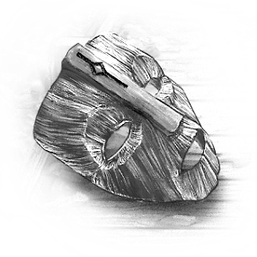

Do you actually

wear a mask yourself

under your umbrella?

Which friends remain

if you are ill for a

long time? Are you

in mourning longer

than socially desirable?

*The rain shows the true colours of things.*

In Venice the truth about a sexual

affair threatened to come to light.



We cleared the air in our relationship.

At a costume ball I see from under my umbrella a crying person with a cows tail near my partner. I want clarification!

Secrets are revealed! The masquerade is over. Deal with it, and leave us alone!

****+ Moon = every cloud has a silver lining

+ Labyrinth = erase your tracks

+ Tower = clearing customs

+ Heart = a pure heart, secret lover

+ Flowers = unwrapping a gift

+ House = house cleaning, spring cleaning

+ Well = secrets made public

+ Sun = rain on some ones parade

+ Child = a crying child, crying like a baby

+ Jellyfish = cleansing, detoxify

+ Lightning = water damage, clean energy

+ Rose = letting go, relieved to let go

+ Pie = organic, less chemicals, purified food

+ Ghost = clear your mind, freeing spirits

+ Gate = releasing your fears

47 Volcano

On this card we see a cute-looking ember bird trying to hide the fact that its internal stress level is rising dangerously high. You can see it is already losing a lot of hot embers.

The ember bird is silent before the eruption, but the volcano behind it, is a severity of unrestrained, released energy.

**Adrenaline, Stress, Anger, Outburst, Irritating, Temperament, Ignite, Overenthusiastic, Sex, Emotional**

It's that feeling at the highest point of the roller coaster as it plunges into the depths.

This explosive power can sometimes be seen in rough sex, it needs no further explanation.

More often you see this energy in the form of anger and aggression in conflicts. This force often comes at the expense of something or someone.

*A volcano can be a repeating wave of violence*

Strong winds delay the Space shuttle launch for hours. The crew can only sit and wait as the tension increases.

When the wind dies out, everyone actively prepares for the launch.

The countdown has begun and the silence before the storm is deafening.



Take-off is a burst of adrenaline and stress makes the crew hyper-alert.

****+ Beggar = being over-questioned

+ Heart = angry heart

+ Huldra = abuse of sex, e.g. Me Too

+ Tree = a hot, sexy body

+ Letter = hate mail

+ Mermaid = energy burst in sports

+ Wave = earthquake

+ Jellyfish = explosion danger

+ Lightning = physical violence, S/M play

+ Lighthouse = a tense atmosphere

+ Pie = burned food, hot food, spicy food

+ Phone = irritated or threatening voice

+ Ouija = adrenaline junkie, thrill seeker

48 Ꝁing

The Kalatian King sits on his simple throne with a jester’s hat in his hand and a jolly bell on his staff. Obviously this man is no longer the king of fools!

He learned from his mistakes and now he is a calm, wise man who has found peace.

**Wise,** **Calm, Balanced,**

**Reliable, Responsible, Thoughtful, Practical, Dignity, Experienced, Compromise, Down-to-Earth**

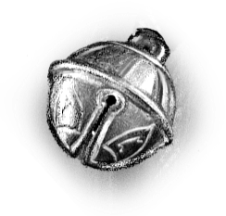To all people, their monarch is like a caring father to them and they like to go

on audiences with the king.

He listens patiently to

the citizens and is aware

that appropriate advice

is a careful consideration

of words.

The calm rival has a cheating device hidden there where the sun don’t shine.

I’m aware of this and thoughtful I’m knighting to a wise position.



Laid back I trust on my experience.

The opponentswell informed queen puts my virtuous king to checkmate.

****+ Clock = take time for something

+ Queen = reliable / intellectual leader

+ Tower = vice squad, moral police

+ Ring = solid / harmonious couple

+ Flowers = patience is a virtue

+ Huldra = moral crusader

+ Crossroads = making a wise choice

+ Past = a fool, naive, credulous

+ Hive = philosopher, professor

+ Child = grandparents, responsible child

+ Lighthouse = moral compass

+ Rose = letting go of the grudge / drama

+ Pie = Thanksgiving dinner, king’s meal

+ Phone = parental advice

+ Ghost = calming silence, parental care

+ Aurora = ancestors, connected by religion

49 Twilight

Welcome to the twilight!

Take a seat on the bench and enjoy the candlelight that gives everything a golden glow. This is your well-deserved downtime.

The candle in the pond shows that all time is finite. The last period of something has arrived. We accept that it’s okay this way.

**Final Phase, Completion, Resignation, Acceptance, Melancholy, Nostalgia, Memories, Remembering, Respite**

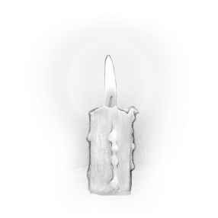

*Eventually all the candle flames will fade out.*

The climate is changing rapidly and the diversity in nature is declining fast.

I was lucky enough to be able to pick all the flowers that life has given me.

I know this bouquet isn't lasting but for now I'm enjoying the comforting scent.

I light a candle and pray that the future generation can reap of what we sow now.

****+ Stars = farewell party

+ Tram = (taking) the last train / bus

+ Clock = the last hours before / until…

+ Tower = final judgment

+ Cocoon = other perspective, different angle

+ House = resting place, retirement home

+ Harbour = emigration, kiss and ride

+ Letter = last will, testament

+ Wave = final warning

+ Pie = the last supper, having a last drink

+ Library = the final chapter

+ Phone = in-depth conversations

+ Scarecrow = compulsive neurosis,

.. the need of having the final check

+ King = with age comes wisdom

50 Aurora

Many Kalatians believe that you should never wave, whistle or sing to the aurora.

It is feared that the aurora will take you away if you attract too much attention.

This is the last card of autumn and also the last card of our year. On the darkest day the aurora appears. It is everywhere!

**Wishes, Amazement, Afterlife, Spirits, Awe, Religion, Everywhere, Internet**

This card is about spirituality and all contact with the afterlife. Gods, angels, guides and the souls of the deceased that we pray to, talk to and to whom we tell our hopes, wishes and thoughts.

And yes, this card can also represent a one way ticket to the aurora to come home where our loved ones are waiting to embrace us.

*Lighthouse & Aurora*

*in a small spread, row or column*   
*indicate:* *spiritually guided*

üüü

Dominant beliefs of others make me feel lost in my own spiritual quest.

Particles everywhere in the sky shape the internet where I can start searching.

With a few keywords I can conveniently find the right information.

Still confused I stop my search and start to meditate to clear my head.

****+ Stars = wishing upon a star,

.. the world wide web around us

+ Thief = overall deficit, scarcity

+ Huldra = karma, what goes around…

+ Crossroads = till death do us part

+ Past = déjà vu, has happened before, past life

+ House = church, spiritual house

+ Wings = enlightenment, relieving, afterlife

+ Well = religious group, zoom meeting

+ Coins = to pay the ferryman = funeral costs,

+ Letter = obituary, email, letters in the ether

+ Wave = overflow, overkill, too much too fast

+ Library = Spiritual book, online study

+ King = God, holy, spiritual guidance

How to use the cards

Now all 52 cards have been introduced to you and we can start.

Ask your question while shuffling the cards. This is how you make contact.

Your guide already knows what you want to ask, so don't worry about the correct wording of your question. It is about the invitation to do a reading together.

I always say how many cards I'm going to take while shuffling the cards and I always ask the question in the same way:

*For the x cards I draw, may I have more information about....?*

This way, you don't have to worry about the exact framing of the question.

Yes or no questions are not so suitable, because the cards make whole sentences.

After shuffling the cards, spread them out and grab the ones that speak to you.

Here you will be led by your guide and try not to think too much, you always pick up the right card! If you can't choose, just shuffle them again and then draw the remaining cards for your spread.

Put them closed in front of you and open them one by one and see what things come to mind first.

*It does not matter in what order you put the cards down in the spread, but you always have to do it in the same way. This is the agreement between you and your guide.*

Now you can start combining cards and so you get multiple words of which you can make one or more sentences.

It is important that you stick to your own question and do not adjust the answer yourself, because it suits you better.

*The cards speak a clear language!*

****Rain + Phone = clear language

The influence of seasons

We speak of a dominating season, when more than half of the cards are from one season in a card spread from four or more cards.

In a three-card spread all cards have to come from the same season to be dominant.

Three same seasons in a small spread, row or column may influence that specific area üüü

*Winter: Slow & No night*

*Spring: Fast & Yes morning*

*Summer: Slow & Yes afternoon*

*Autumn: Fast & No evening*

But what is exactly the influence of the seasons? Here’s a picture question for that:

*what will happen with my job?*

In a nine-card spread with five same season cards dominating we find this combination:

Thief + Hive = Reduction + Work

That sounds worrying right?

But now let’s take a look at what the meaning could be per season:

****An employee is stealing your job or your work from you. This may mean that you cannot continue.

A colleague relieves you with work so that you can get more work done.

Someone helps you with your tasks so you can take it easy, to relax a bit.

An intern / trainee does your job better and faster and that frightens you. Does this affect your job?

As you can see, a dominating season can greatly change the explanation of the cards.

Winter is working against us!

Spring is brimming with energy!

Summer is long, lazy enjoyment!

Autumn lets us meet ourselves!

Which spread to choose?

Now you know what influences seasons have and you know the complexity of your question so you can choose which laying pattern / spread suits you best.

ü 1 card can add info to an existing spread.

ü ü 2 cards are fine for the yes/no questions

or slow/fast timing. Look at the seasons.

(note that no clear answer means: no answer)

ü ü ü 3 cards are great for a simple question.

Read them as a sentence as shown in

the summer on page 63.

ü ü ü ü ü 5 cards give a very good sentence

with more information. Read all cards as pairs 1+2, 2+3, 3+4 etc. where the second card is the subject. Make a sentence out of these combinations. Cards 1+5 and 2+4 can check the given info or add extra depth.

**⸫** *Pay attention to whether a season is dominant!*

The 9 - card spread

This spread is important because you also use it to read the large Table of Seasons.

Shuffle, spread out & randomly pick cards…

Card 5 is the central card and the main topic

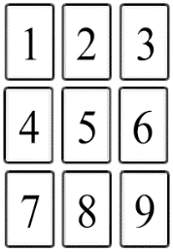1+4+7 = past

2+5+8 = present

3+6+9 = future

1+2+3 = your concerns

4+5+6 = current approach

7+8+9 = guidance you get

Corners 1+3+7+9 = the first impression

Diamond 2+4+8+6 = dynamics around card 5

3+5+7 = pitfall *for you to watch out for*

1+5+9 = strategy *you might want to consider*

**⸫** *Pay attention to whether a season is dominant.*

*Example: Even a spread with 6 out of 9 cards in winter could still end very energetic and fruitful when it has three cards of spring in the future.*

Table of Seasons

With this spread, all 52 cards come to the table and they take place in positions we call *houses.*

For these *houses* we have to imagine that all cards are already on the table in four rows of the 13 cards per season and in order from first winter card 51 to the last autumn card 50.

These positions are fixed and never change!!

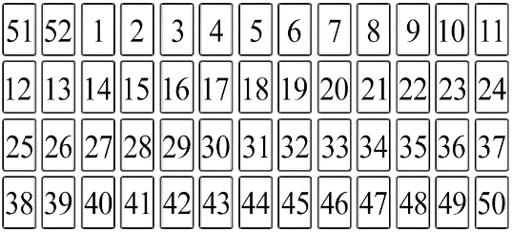

On top of these imaginary positions of the *houses* we place our 52 shuffled Kalat cards. These *houses* give information about the card that is on top of it and stands for the subject.

Example: The card Heart lies on our imaginary *house* of the Broken Bridge [5]

This location is the 7th *house* of winter.



Bridge + Heart = a broken heart

With this spread you do not ask a question in advance but you pick a card as a subject. You look at the cards around it and you can interpret the cards as if it were a smaller card spread. You can do this with all the cards.

All cards can be used as a subject card:

Heart = love, Queen or King = parent(s), Harbour = journey, Coins = money, etc…

Example: If you want to know more about work, take a look at the work card: the Hive. Together with the 8 cards around it you can now do a 9-card spread.

**⸫** *Houses do not have seasonal influence!!!*

Knighting

The knight ♞ (a piece in the game of chess)

moves two squares vertically and one square horizontally, or two squares horizontally and one square vertically. This technique takes you to new cards that provide valuable info.

Example: Knighting the broken heart card on the 7th *house* of winter, (the [5] *broken bridge*)

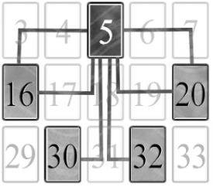can take you to four

different locations:

Let’s look at the

5th *house* of Spring **»**

The *house* of the

Äskling Past [16]

with the Coins card

on top of it. This combination could mean:

A broken heart by someone who had money or a break up due to the cause of money.

**⸫** *I love knighting and I always use it for extra info.*

The Trail

There are some secret trails that run through the Kingdom of Kalat. Let's follow one!

We start at the 5th *house* of spring.

(the money-person *we* *found with knighting*)

We find the trail by repeatedly search for that card that corresponds to the previous *house*.

Coins + *Past* = was a rich person / rich past

Past + *Ring* = person is bound / committed

Ring + *Tower* = committed to the company

Tower + *Beggar* = the company is *ailing*

*This person broke someone’s heart* *because all the attention is focused on an ailing company that has all its own money in it and that hän cannot yet let go of.*

Season trail: Have you noticed that a large part of the trail runs through the winter?

That's very enlightening, don’t you think?

**⸫** *Why don’t you try the trail of the Äskling*

*Future for yourself and see where it takes you?*

Äsklings Past & Future

Both Äsklings represent the querent!

Combine the cards in the column(s) of both Äsklings as they represent the present.

*(even if they are in the same column)*

Combine the two cards that the Äsklings are facing to get valuable information about the querent. The Äsklings act as a kind of bridge.

All cards in the columns left of the Äskling Past represents the past of the querent.

All cards in the columns right of the Äskling Future represent the future of the querent.

If the Äsklings are facing each other,

a few cards in between them (also diagonal!) can give information about what binds them.

Looking away, the cards in between may speak of what separates the past and future.

If we parse the table of seasons into 9-card spreads then the Äskling can also stand for a person in the querents life.

Gender

Äsklings cards have no gender but represent the querent or someone in their life.

I made this choice because for me it’s not important what someone's gender is.

If you find it useful to know genders then you can look at a season and consider this:

Maybe spring has more masculine energy?

Focused on future goals, starting things, making adjustments along the way.

Believing that everything will be fine.

Maybe autumn has more feminine energy?

Based on past experiences, going through all possible scenarios. How to deal with them. Making predictions about the outcome.

Feminine / Masculine energy is not the same as gender! That's why I mainly look at the surrounding character cards or the *houses*

to know who we are talking about.

**⸫** *And we can always just ask the querent.*

53 Mirror Cards

The three mirror cards are an extra bonus in this box. They can be used in a reading if you have a question about a deceased person, child or animal.

I wanted to give a face to all loved ones, who have passed away and left us incomplete.

We see them in the mirror because they are a part of us forever. In front of the mirror we also see the empty space they leave behind.

For these cards I chose very personal portraits. I hope they can represent your loved ones too.

The dog is my first dog Ina, she died age 14. She was a true cairn terrier. Her stubbornness made me laugh and is what I miss most. You see it in her face…

The child is my aunt Heidi. She died at the age of 4. For me this card is also a gift to my mother and her siblings. Now they have this card as a small memory to their little sister.

The woman who is portrayed, is my inspiration, Sirpa. She showed me the way out, to pursue your dreams, to experience life. Cancer took her away from this world at the age of 74. With this card I can say thank you.

I hope the portrait of this beautiful Finnish lady can represent the person who is missing in your life.

After laying the Kalat cards on the Table of Seasons you can put your mirror card on top of the card that lies on the *house* of the ghost in the Table of Seasons.

This location is the 5th *house* of autumn.

Now this location has two functions.

1: The original *house* of the ghost gives information about the card on top of it.

2: The original *house* of the ghost expires and the card on top of it now becomes the new *house* for the mirror card that you put on it.

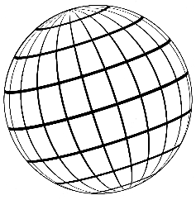Sphere of Seasons

The table of seasons can

be imagined as a sphere

without beginning or end.

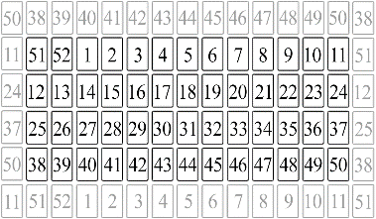

This sphere

creates an

infinite field

of *houses*

With this larger field we can also read small spreads with *houses*. Imaginary you place the centre card of your spread on the corresponding *house* of the sphere

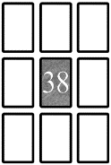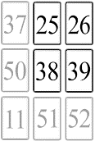







**⸫** *The centre card lands on its own house*

*and that house therefore has no effect.*

Now all the cards of your spread are on a *house* and you can interpret them as always.

For this technique you need to know the Sphere of Seasons by heart!!

*For the beginner keep page 134 close by to help you.*

I know it's a challenge to memorize so many cards and their positions and that's why I gave all the start, middle & end cards per season a time-location marker

All four cards from the same time location in

a 9-card Spread can give extra information.

*Moon, Flowers, Sun & Rose*

*are the starting cards of seasons, they may indicate: start, starting, starters*

*Bridge, Wings, Mermaid & Scarecrow*

*are the midseason cards, they may*

*indicate: highly sensitive personality (HSP),*

*the influence of changing external energies*

*Heart, Traveller, Lighthouse & Aurora*

*are the cards of season endings, they may indicate: end, endings, quitters*

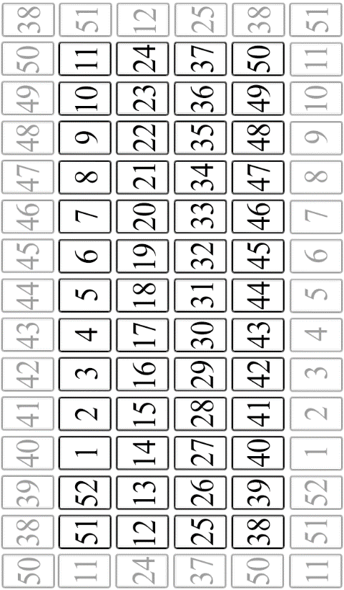

**⸫** *Always thank your guide after a reading !*

Now we have come to the end of this booklet. I hope you are inspired to start using this deck and discover all the possibilities.

I have done my best to tell as much as possible and explain clearly, but I would like to invite you to also follow my website with much more information, tips and tricks.

www.kalat.world

In this deck went blood, sweat and tears, but above all a lot of attention, love and care from the entire Kalat team: @kalat.world

@inge_illustration

@verheesroel

A Royal thought:

*Former Dutch Queen Juliana is often*

*characterized as the queen next to the red*

*carpet. She was headstrong and averse to*

*protocol. With my deck I offer you some*

*ground rules. This is the method I follow.*

*Think of it as a red carpet that you can walk*

*next to. Follow your own feeling and set your*

*own rules.*